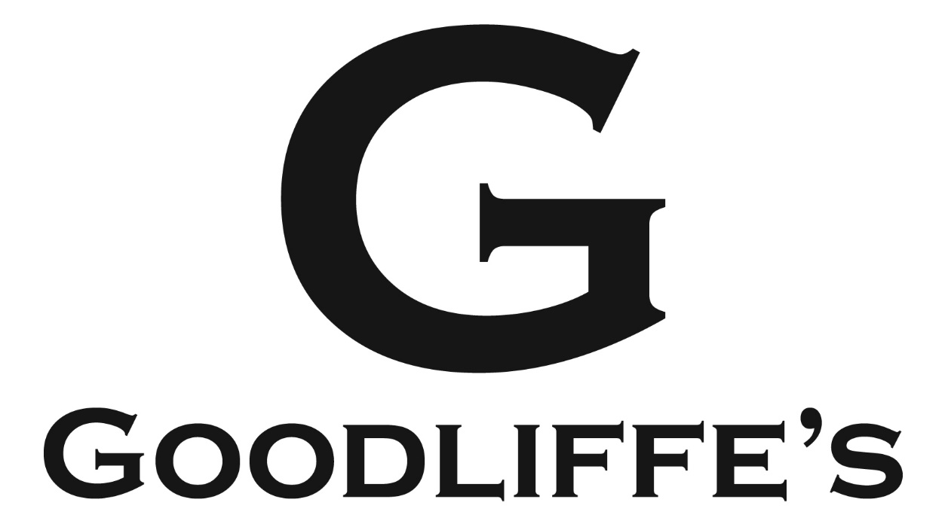

Covid-19 Risk Assessment

June 2020

Risk Assessment

Name of business: Goodliffe’s

Hazard
COVID-19 (Potential Spread)
COVID-19 is a respiratory disease caused by a virus that gets into the lungs. It does this directly from droplets praying from an infected person usually this will be face to face close contact i.e. within 1 meter onto another person and causes an illness which may be asymptomatic, mild, moderate, severe or fatal and this could affect staff, customers, contractors, suppliers and visitors to the business. If the infected person coughs or sneezes the droplet can travel further.
In the early stages of the infection most people don’t have any symptoms but can be shedding virus particles. Latest data suggest that seven out of 10 of those who have tested positive for coronavirus had no symptoms at all. We must therefore treat everyone as a potential carrier of the virus.

Main Controls:
- Making sure that people with symptoms do not enter the business
- Social distancing
- Increasing the frequency of cleaning hand contact surfaces
- Increasing the frequency of hand washing and practicing respiratory hygiene

Temperature Testing, Face Coverings and Gloves

The precautionary use of additional PPE beyond what is usually worn is not recommended. They can lead to a false sense of security and social distancing and hand washing are much more effective controls.
Face coverings only provide some benefit if everyone wears them and in small enclosed spaces e.g. on buses and trains this is now required. They do encourage wearers to touch their face more regularly and they need safe disposal. Medical grade PPE is in short supply and should not be worn outside clinical settings. Gloves will be contaminated the same way that bare hands are. They are only effective if they are replaced after each use. Effective washing of hands when they may have been is the best control measure.
Temperature testing staff should be treated with caution. It is not an accurate way of determining if someone if free from COVID-19. Infra-red thermometers do not have a high degree of accuracy, there is a risk of false negatives (i.e. high temperature for other reasons) and as above, up to 70% of people carrying COVID-19 do not have any symptoms and not everyone experiences a high temperature as a symptom of COVID-19.

Step | Suggested Control Measures | Controls in My Business
Preventing the virus from entering the business. | - Return to work interviews by phone to identify employees who should not return i.e. the high-risk shielding group and those who live with them.  - Ongoing Personal Risk Assessments for new and expectant mothers and those who are at increased risk of severe illness from COVID-19. Reasonable adjustments must be made, and they must take extra care in observing social distancing whilst at work.  - Staff must not come to work if they have the COVID-19 symptoms and must self-isolate for 7 days or if someone they live with has the symptoms (14 days self-isolation).  - If they develop symptoms whilst at work, they must inform their manager and go directly home and self-isolate for 7 days.  - Uniforms and work clothes must freshly laundered and not be worn on public transport. If public transport is used, staff must change into their work clothes on arrival.  - Measures will be put in place to ensure that customers are as far as reasonably practicable free from COVID-19 before entering the business including:  - A notice should be displayed requesting that customers do not enter if they have symptoms of COVID-19.  - Hand sanitiser placed at entrances with a notice to encourage customers to use them before entering.  - All contractors and visitors must abide the rules of personal hygiene and social distancing whilst on the premises. A signing in record is required.  - Social distancing controls to be observed when taking in deliveries of food and drink. | - Managers to speak to employees prior to returning to work completing a back to work questionnaire  - Managers to converse with employees to reassure and support employees in a fast changing situation  - Initial staff training  - Staff informed of procedure of reporting COVID-19  - Staff informed of details of how to apply for NHS test  - Initial staff training and ongoing communication  - List of staff that use public transport to get to work and for them to look for an alternative method. Staff that use public transport to look for an alternative method of getting to and from work  - Clean uniforms to be worn daily by all members of staff  - Staff to change into uniform on the premises  - No mobile phones permitted in any areas other than the staff room  - A notice will be displayed at the front door  - Hand sanitiser is placed at all entrances  - Deliveries will be made to a dedicated delivery area using social distancing – Signing in book for any delivery or contractors to be on the kitchen door  - One person will be allocated to accepting deliveries

Step | Suggested Control Measures | Controls in My Business
Reducing the risk of transmission | - As far as possible, staff will work at one site only to restrict the number of colleagues interacting with each other.  - Every reasonable effort must be made to comply with the social distancing guidelines set out by the government (2m or 1m with risk mitigation where 2m is not viable)  - Where the social distancing guidelines cannot be followed in full in relation to a particular activity, all mitigating actions possible will be taken to reduce the risk of transmission between staff, customers, contractors, suppliers and visitors by:  - Increasing the frequency of hand washing and surface cleaning,  - Keeping the activity time involved as short as possible,  - Using back to back or side to side working rather than face to face whenever possible,  - Where staff live in the same household, social distancing will not be needed e.g. in kitchens or behind the bar. You should communicate this to your customers to avoid any concerns.  - The social distancing measures will apply to all parts of the business, not just where staff usually work, but also entrances and exits, changing areas and team rest areas, smoking areas etc.  - A ‘one person only rule’ for small spaces will be applied as appropriate to the back office, team rest room, stock rooms, changing rooms, walk in fridges and freezers etc.  - As far as possible the sharing of equipment will be avoided. Where equipment needs to be shared it must be wiped down with sanitiser on a clean cloth before and after each use.  - Tables both inside and outside should be identified as those that can and cannot be used to maintain social distancing. Tables outside should be removed to provide the required distance between guest. Additional tables and chairs can be provided in gardens and car parks if the licensing rules permit.  - Where possible making use of available doors, plan a one-way system for entry and exit and where possible a separate route of entry to use toilets. Plan where customers will safely queue with the objective of limiting queueing inside. Signs should be used to help customers to understand where to queue and navigate the one way system.  - During busy times a host/greeter will be required to control entry when capacity is reached. Lines should be marked outside to manage social distancing for customer queueing to enter.  - Floor markings must be placed at till order points so that customers know where to stand to keep the required distance from the staff taking orders. Customers will not be permitted to stand at the bar once they have been served  - All indoor customers must be seated. Customers outside may sit at tables, chairs and benches or stand in appropriately space standing room.  - In the event of adverse weather, customers outside will not be permitted to seek shelter indoors when capacity is reached  - Toilets – notices should be provided requesting that customer respect social distancing whilst using the facilities.  - Where the facility is available, customers should be invited to book in advance so capacity can be managed and staggered.  - Disposable menus or chalk boards should be used. Condiments will be provided in sachets/rip pots or ramekins. | - Initial staff training session to reinforce this  - Only one person to work behind the bar at a time  - Staff training to reinforce importance of handwashing  - Table service to stop customers coming to the bar. Customers will be seated at all times within the pub  - We will have hand sanitiser behind the bar  - Timer will be set to 30 minutes to remind all team to wash hands  - Social distancing guidelines will be followed and tables taken out or spaced out to create more distance between customers.  - A manager will meet customers and take them to their allocated table  - All seats are at least 1m apart  - Managers will remind customers of company procedures on entering the restaurant and remind them to maintain social distancing  - Social distancing will be stressed at initial team meeting and have posters around the building  - Posters on stock room and cellar doors to stress only one person at a time.  - Staff will be reduced in certain areas to comply with social distancing measures  - Review work schedules and alter start and finish times/shift patterns  - Staff will be assigned to set locations where they remain for their shift  - Wipes will be behind the bar to wipe tills and PDQ machine  - Staff will take rotated breaks  - Social distancing of staff will take place in all areas  - Tables inside and out will be moved to 1m apart – these will be checked daily  - We have calculated our maximum number inside as 41 and outside as 33 guests  - We will have a one way system in place; using the doors to the beer garden as the outdoor and the front door as the main in door with hand sanitiser available at both  - The manager will do this on busy periods  - Guests will be seated according to table plan maintaining social distancing  - No orders will be taken at the bar, we will operate a table service only customers will be asked to take a seat as soon as they enter the premises a sign will be displayed  - Posters on external doors to garden explaining that during bad weather customers may not be able to come back in due to capacity numbers  - Disposable menus will be used and will be disposed of after use.  - All condiments will be in sachets

Step | Suggested Control Measures | Controls in My Business
Reducing the risk of transmission (continued) | - Contactless payment should be encouraged.  - No live music will be booked or planned . Background music and TV sport must be on a low volume so that normal conversation is possible without raising the voice. Customers will be discouraged from singing, shouting or chanting to mitigate against the risk of aerosol transmission.  - Manager should check daily before the team arrive for work that hand washing facilities are available and adequately supplied and supplies of disposable cleaning cloths, blue roll and sanitiser spray is made up and ready for both Front of House and Kitchen.  - As the team come on shift the manager should confirm their health status, correct clean uniform is worn and the team have been briefed on the social distancing measures, enhanced hand washing and cleaning duties.  - An enhanced cleaning regime should be implemented. Including sanitising tables, chairs and highchairs each time they are turned and a regular wipe down of hand contact surfaces behind the bar, front of house, toilets and kitchen areas.  - Non fire doors to be wedged open to reduce touchpoints.  - Air circulation front of house will be maximised by opening windows and doors to provide ventilation where possible.  - The size of bar will determine how many staff can work safely in the space and observe social distancing. Staff must step back to allow customers to make payments and pick up drinks.  - Bars must set up so that each bar tender can have their own workspace to meet the social distancing requirement. Glassware and fridges need to be stocked so that staff do not need to cross over each other.  - In small kitchens a limited menu should be designed that will allow the cook line will be a single person operation.  - In larger kitchens the cookline will be likely be limited to a two-person operation. A 'starting chef' who will complete the majority of the cooking and a 'finishing chef' who will do final plating, starters and desserts. Cross overs must be minimised  e.g. for hand washing and where necessary completed back to back.  - Access to kitchens to be minimised to as few people as possible. In most kitchens this will be restricted to a single front of house staff member at a time. In/Out doors to be used where provided.  - Contact at the pass and pot wash area to be minimised by the kitchen staff stepping away to allow the front of house staff to pick up food orders or drop off dirty plates etc.  - Ensure staff know and understand how to manage a situation when customers fail to follow the processes put in to place to protect people’s safety. If a customer’s actions put another customer or staff at risk this should be referred to the manager and dealt with using conflict management and the right to refuse service. | - We will encourage contactless payments, where this is not possible the card machine will be sanitized before and after payment is made  - We have adjusted our pre-opening checklist to include this  - Stringent hand washing to take place  - Employees to be reminded every 30 minutes to wash their hands also following any contact with surfaces or interactions with customers.  - Employees to also use hand sanitizers  - Managers to carry out checks and give briefings on hand washing/sanitizing and social distancing measures  - All staff have been trained on the enhanced cleaning procedure. Using our 30 minute timer we will clean behind the bar and wash hands. Tables, chairs etc will be cleaned with sanitizing spray after each customer leaves  - Done  - Included in pre-opening checklist  - When possible both back and front doors will remain open  - Not possible, bar too small so see above, one person behind the bar at a time.  - Where possible we will avoid customers coming to the bar  - Restocking will be carried out in quiet periods and at the end of the evening – Bars to be fully stocked for the start of the day  - Menu reduced and small teams created  - Smaller kitchen staff teams have been created  - One staff behind the bar and one staff to take food from the kitchen. We cannot have and in/out door. But chef will put food under seat lamps and then call for staff, then move away from the pass  - One staff in the kitchen will manage limited menu and washing up. Waiting on staff (1) will leave dirty dishes at the identified location (away from the chef)  - Initial staff meeting – staff will inform manager of any customers not following the rules. They will be issued a warning by the manager to customer, repeat offenders will be asked to leave.

Step | Suggested Control Measures | Controls in My Business
Reducing the risk of transmission (continued)  Test and Trace | - Back office equipment will be shared by the smallest number of staff as possible. Keyboard, mouse, door handles, safe etc. should all be sanitised before and after use.  - To assist NHS Test and Trace we will keep records of staff rota information for 28 days, contractors and visitor visits and participate with the Government designed system collecting and keeping temporary records of customers for the required period. | - One person at a time in the office and is responsible for wiping equipment down after use.  - We will ask customers for their name and address when we take booking or their first order at the table

Sign off
I have carried out a COVID-19 risk assessment and shared the results with the people who work here (see over)

Signed: |  | Print Name:
Date: |  | Job Title:

Team:
I understand the controls that I must follow as outlined in the risk assessment above:

Team Member Name: | Signature: | Date:

